What is domestic abuse?
Domestic Abuse Act 2021

Behaviour of a person (“A”) towards another person (“B”) is “domestic abuse” if—
(a)A and B are each aged 16 or over and are personally connected to each other, and
(b)the behaviour is abusive.

(3)Behaviour is “abusive” if it consists of any of the following—
(a)physical or sexual abuse;
(b)violent or threatening behaviour;
(c)controlling or coercive behaviour;
(d)economic abuse
(e)psychological, emotional or other abuse;

It does not matter whether the behaviour consists of a single incident or a course of conduct.

.

Personally Connected is defined as:
  - they are, or have been, married to each other;
  - they are, or have been, civil partners of each other;
  - they have agreed to marry one another (whether or not the agreement has been terminated);
  - they have entered into a civil partnership agreement (whether or not the agreement has been terminated);
  - they are, or have been, in an intimate personal relationship with each other;
  - they each have, or there has been a time when they each have had, a parental relationship in relation to the same child (see subsection (2));
  - they are relatives.

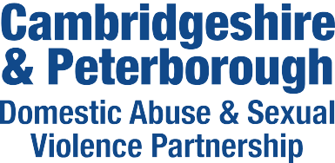

Health IDVA Information for professionals

What is an IDVA?
An IDVA (Independent Domestic Violence Advisor) works with current victims of domestic abuse to:
  - identify and assess risks
  - understand and access options
  - devise bespoke safety plans
  - navigate criminal and civil justice processes

They have an in-depth understanding of the dynamics of domestic abuse, including the impact on victim/survivors and the tactics and behaviours of perpetrators. They provide practical advice and emotional support to victim/survivors of domestic abuse, acting as their advocate when needed.

What is a Health IDVA?

Health IDVAs provide a specialist service working with all community and, hospital-based Health services across Cambridgeshire only (not Peterborough).

The team accepts referrals at all risk levels where there is current domestic abuse or separation in the last 3 months following a relationship where the victim was subjected to abuse. Referrals must be from professionals.

They can also provide advice and information to professionals.

What is a MARAC?
MARAC is a multi-agency risk assessment conference to review the highest risk DA cases. The referral forms can be downloaded from our website under the ‘Professionals’ section:

http://www.cambsdasv.org.uk/

.
IDVAs can help with
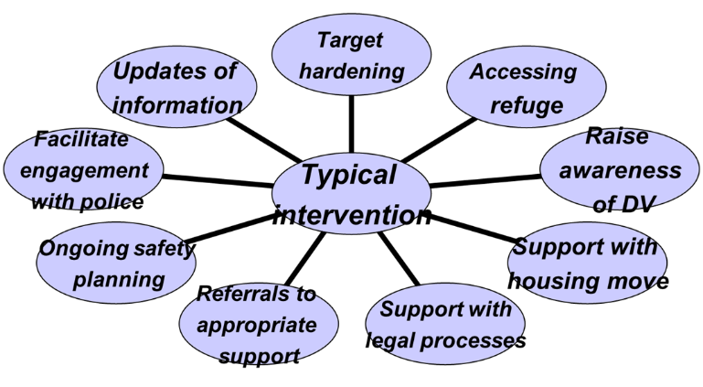

To contact the Health IDVA:

Please contact the Health IDVA on:
Mobile 07713 919229

or email idvacambs@nhs.net

