Cambridgeshire and Peterborough Domestic Abuse
and Sexual Violence Partnership
Safe Accommodation Needs Assessment
2021

Contents
Introduction 3
DA Support Services 5
Incidents and Homicides 24
Domestic Abuse by area 27
Refuge Accommodation & the Bobby Scheme 35
Housing options in Cambridgeshire & Peterborough (beyond emergency accommodation) 42
Case Studies 52
Conclusions and Recommendations 62
Appendix 1: ‘DASV: Safe Accommodation Needs Assessment Survey- April 2021 63

Table of Figures
Figure 1: DA victims by Age 8
Figure 2: DA Victims by Age (Cambridge Women’s Aid) 8
Figure 3: Male and Female DA rates total count 10
Figure 4: UK domestic homicide rates by gender 11
Figure 5: Cambridgeshire and Peterborough IDVA Service by Gender 11
Figure 6: Local support service referrals by gender 11
Figure 7: Local support service referrals by marital status 13
Figure 8: Ethnicity of clients using support services 17
Figure 9: National identities East of England, Cambridgeshire, and Peterborough July 2019-June 2020 18
Figure 10: IDVA and MARAC referrals by nationality 18
Figure 11: Cambridgeshire and Peterborough IDVA service- Clients and their children 19
Figure 12: Cambridgeshire and Peterborough IDVA Service- Number of children per client 20
Figure 13: DA Children's Referrals (DA primary factor) outcomes 20
Figure 14: Languages spoken- IDVA and MARAC Data 22
Figure 15: DA Incident Cambridgeshire Constabulary 24
Figure 16: ONS Domestic Abuse Data Tool 2020- Incidents in Cambridgeshire and comparable areas 24
Figure 17: Suspects of female and male homicides 26
Figure 18: Cambridgeshire and Peterborough Domestic Homicide and Suicide rates 26
Figure 19: IDVA referrals by Area 2019/20 28
Figure 20: MARAC referral numbers by area 29
Figure 21: Proportion of Cambridgeshire population and Peterborough population in Rural areas (Census 2011) 30
Figure 22: Referral areas for refuge accommodation 32
Figure 23: Bobby Scheme feedback from clients 2020/21 34
Figure 24: Client housing type before refuge 36
Figure 25: Clients staying in refuge- number of children (those listed as pregnant may also have other children) 37
Figure 26: Ethnicities of those staying in refuge 38
Figure 27: Client disability type in refuge accommodation 39
Figure 28: Additional Vulnerabilities of clients in refuge accommodation 40
Figure 29: DA Victims on housing register 2020/21 by Age 42
Figure 30: DA victims on housing register 2020/21 by Age in Huntingdon 43
Figure 31: Victims of DA on housing register by Gender 43
Figure 32: Accommodation at time of approach for Victims of DA on housing register 44
Figure 33: Victims of DA on housing register by Sexual Identity 44
Figure 34: Disibility type recorded for victims of DA on Housing Register 45
Figure 35: Ethnicities of victims on housing register in East Cambs, South Cambs, Cambridge City, Fenland, Huntingdon 46
Figure 36: Top 5 Nationalities (not including UK National) of DA Victims on Housing register- South Cambs, East Cambs, Cambridge City and Fenland 46
Figure 37: Peterborough housing register- DA clients household structure 47
Figure 38: Victims of DA on housing register- dependent children 48
Figure 39: Victims of DA on Huntingdon housing register- total number of people in client's household 48
Figure 40: Bedroom need for victims of DA on housing register (east cambs, south cambs, fenland and Cambridge city) 49
Figure 41: Victims of DA on South Cambs housing register- ages of dependent children 49
Figure 42: Occupation of main applicant (DA victim) on housing register 50
Figure 43 52

Introduction

1.1 Sources
Agencies that provided information for the need’s assessment included-
- Aspire Peterborough Change Grow Live (CGL)
  - Service users where DV was a relevant factor
- Bobby Scheme
  - Referral numbers
  - Details on those supported by service
- Cambridge City Council Housing
  - Housing register where DV was a related factor
- Cambridgeshire Constabulary
  - Victims of DV
- Cambridgeshire County Council (CCC) Adult Social care
  - Referrals where DV was a relevant factor
- CCC Children Social care
  - Referrals where DV was a relevant factor
- CHS Group (housing, care, and community services in Cambridgeshire)
  - Case studies on DV
- Community Against Domestic Abuse (CADA)
  - Case study on DV
- Community Rehabilitation Company Probation
  - Service users who are victims of DV
- Independent Domestic Violence Advisory (IDVA) Service
  - Snapshot of open cases
- Multi-Agency Risk Assessment Conference (MARAC)
  - MARAC referrals
- East Cambridgeshire Housing
  - Housing register where DV was a related factor
- Fenland Housing
  - Housing register where DV was a related factor
- Huntingdon Housing
  - Housing register where DV was a related factor
- Peterborough Housing
  - Housing register where DV was a related factor
- Rape Crisis Partnership
  - Service Users where DV was a related factor
- Refuge
  - Referrals
  - Victims in refuge
  - Victims supported by Outreach
- Sexual Assault Referral Centre (SARC)
  - Service Users where DV was a related factor
- South Cambridgeshire Housing
  - Housing register where DV was a related factor
- Women’s Aid Cambridge
  - Referrals
  - Victims in refuge
  - Victims supported by Outreach
- Women’s Aid Peterborough
  - Referrals
  - Victims in refuge
  - Victims supported by Outreach
- Office of the Police & Crime Commissioner
    - One Voice for Travellers
    - The Meadows Child & Family Wing
    - Cambridgeshire Deaf Association
    - NSPCC
    - Choices
    - Family Action

Thank you to Heather Williams for liaising with all partner agencies and developing this Needs Assessment.

DA Support Services

  - 2.1 Data
Data sets are provided from the following support services for year 2020/21.
- Adult Social Care
- Aspire Peterborough CGL
- Cambridgeshire Constabulary
- Children’s Social Care
- IDVA Service
- MARAC
- Probation
- Rape Crisis
- Refuge Outreach
- SARC
- WA Cambridge Outreach
- WA Peterborough Outreach
- Office of the Police and Crime Commissioner
It is very likely that some victims will be counted in numerous data sets as they will have used more than one of the services above.
Data from the Victim and Witness Hub will not be commented on in this report as the numbers detailed are not just victims of Domestic Abuse. However, they have informed us that in 2020/21 they supported 647 victims of DA which represents 19.1% of the total number of victims supported in the Hub. The Victim and Witness Hub provides emotional and practical support to victims and witnesses to crime. They will support victims of crime where there is standard risk of DA.
  - 2.2 Summary of Datasets
The table below gives an indication of what data was provided from the sources listed above-

 |  | MARAC | Adult Social Care | SARC |  | Cambridgeshire Constabulary | Probation/ Victims | Rape Crisis | Refuge Outreach | Aspire Pet CGL | WA Pet Outreach | IDVA | WA Cam Outreach | Children’s Referrals
Age | Recorded? | Yes | Yes | Yes | Yes |  | Yes | Yes | Yes | Yes | Yes | Yes | Yes | Yes
Age | % unknown for source | 0.08% | 0% | 0% | 0.4% |  | 3% | 0% | 4% | 0% | 0% | 0.6% | 15% | 0%
Gender Identity | Recorded? | Yes | Yes | Yes | Yes |  | Yes | Yes | Yes | Yes | Yes | Yes | Yes | Yes
Gender Identity | % unknown for source | 0.08% | 0% | 0% | 2% |  | 0% | 0% | 0.1% | 0% | 0% | 0.2% | 5% | 3% unborn
Marital Status | Recorded? | No | No | Yes | No |  | Yes | Yes | Yes | Yes | No | Yes | Yes | No
Marital Status | % unknown for source |  |  | 0% |  |  | 17% | 35% | 44% | 23% |  | 7% | 22%
Sexual Identity | Recorded? | No | No | Yes | No |  | Yes | Yes | Yes | Yes | Yes | Yes | Yes | No
Sexual Identity | % unknown for source |  |  | 0% |  |  | 14% | 53% | 24% | 31% | 25% | 2% | 54%
Disability | Recorded? | Yes | No | Yes | Yes |  | No | Yes | Yes | Yes | Yes | Yes | Yes | No
Disability | % unknown for source | 6% |  | 0% | DR |  |  | 30% | DR | 23% | 55% | DR | 49%
Ethnic Group | Recorded? | Yes | Yes | Yes | Yes |  | Yes | Yes | Yes | Yes | Yes | Yes | Yes | Yes
Ethnic Group | % unknown for source | 8% | 8% | 0% | 24% |  | 3% | 32% | 26% | 0% | 0% | 9% | 0% | 2%
National Identity | Recorded? | Yes | No | Yes | No |  | Yes | Yes | No | No | No | Yes | No | No
National Identity | % unknown for source | 4% |  | 0% |  |  | 1% | 39% |  |  |  | 7%
Household Structure | Recorded? | No | No | No | No |  | No | Yes | No | No | No | Yes | Yes | No
Household Structure | % unknown for source |  |  |  |  |  |  | 0% |  |  |  | 1% | 0%
Occupation | Recorded? | Yes | No | No | No |  | Yes | Yes | Yes | Yes | No | Yes | No | No
Occupation | % unknown for source | 25% |  |  |  |  | 30% | 44% | 68% | 0% |  | 51%
Household Income | Recorded? | No | No | No | No |  | No | No | No | No | No | No | No | No
Children | Recorded? | Yes | No | No | No |  | No | No | No | No | No | Yes | Yes | No
Children | % unknown for source |  |  |  |  |  |  |  |  |  |  | DR | DR
Education | Recorded? | No | No | No | No |  | No | No | No | No | No | No | No | No
Education | % unknown for source
Language | Recorded? | Yes | No | No | No |  | No | No | No | No | No | Yes | No | No
Language | % unknown for source | 2.75% |  |  |  |  |  |  |  |  |  | 1%

  - 2.3 Age
KEY FINDINGS
- The largest age group using DA support services in the Cambridgeshire and Peterborough area is people between the age of 25-34. (see figure 1)
- As the age increases the number of clients using the services decreases, numbers decrease considerably from age 55 onwards. (see figure 1)
- Being older appears to be a barrier to accessing and benefiting from DA support services.
Figure 1: DA victims by Age

Figure 2: DA Victims by Age (Cambridge Women’s Aid)

2.3.1 Age as a barrier
Older age groups are under-represented in local data regarding who is seeking and accessing support for DA.
There could be several reasons for lower numbers of older people using DA support services including differing attitudes about marriage and private life that may differ from younger generations. For example, believing that marriage is for life and that their private life should not be in the public sphere. Moreover, there is often an unwillingness to report the abuse where it is being perpetrated by their adult child.
There could also be increased vulnerabilities, for example financial, whereby the survivor does not have control of their own finances and everything is in their partner’s name. Also, this group may be more isolated because of their age, e.g. they do not socialise as much or go to work. This could mean there is less opportunity to reveal the abuse as they may never have time away from the perpetrator.
In addition, where an older person relies on support from a family member in a caring capacity this can be used to disguise abuse. The carer may insist on being present at all appointments with professionals and the survivor may be fearful of what will happen to them if they report the abuse (ie will they have to go into residential care or have professional carers).
  - 2.3.2 National Evidence
- Safelives emphasises in a 2016 report that on average, older victims experience abuse for twice as long before seeking help as those aged under 61. Victims aged 61+ are much more likely to experience abuse from an adult family member or current intimate partner than those aged 60 and under yet older clients continue to be hugely underrepresented among domestic abuse services.
- Another vulnerability is having care and support needs that could arise if the victim has a disability, which according to Safelives nearly half of older victims have, for a third this is physical. Research suggests that the potential for violence within a carer’s relationship increases when the carer is an intimate partner or close relative. (Livingstone et al., (1996)
2.4 Gender Identity
KEY FINDINGS
- Female victims of DA are at higher risk than male victims.
- The majority of victims of domestic homicide between March 2016-March 2018 were female (74%).
- Nationally, the Crime Survey for England and Wales for year ending 2020 has reported that around 1/3 of victims of DA are male and 2/3 female.
- Locally, for year ending 2020, Cambridgeshire Constabulary recorded that just under 1/3 victims of DA were male and 2/3 were female. (Note: DA incidents recorded will also include familial violence, e.g. brother assaulting another brother)
- Men, non-binary, and transgender persons are under-represented among DA support services.
Figure 3: Male and Female DA rates total count
Victims of DA by Gender | CSEW Year Ending March 2020 | Percentage of total |  | Cambridgeshire Constabulary Year Ending March 2020 | Percentage of total
Female | 1,600,000 | 68% |  | 4866 | 69%
Male | 757,000 | 33% |  | 2022 | 29%
Other/ Unknown |  |  |  | 191 | 3%
Total | 2,357,000 |  |  | 7079

It is worth noting, that within Cambridgeshire in 2013/14, approximately 25% of all police-reported incidents (c.1905 of 7620 in total) of domestic abuse were reported by men. However, this reporting rate fell to 6% where medium and high-risk cases only were assessed by frontline police officers.
Women tend to be higher risk victims, which is highlighted by the rate of domestic homicide shown in the table below.
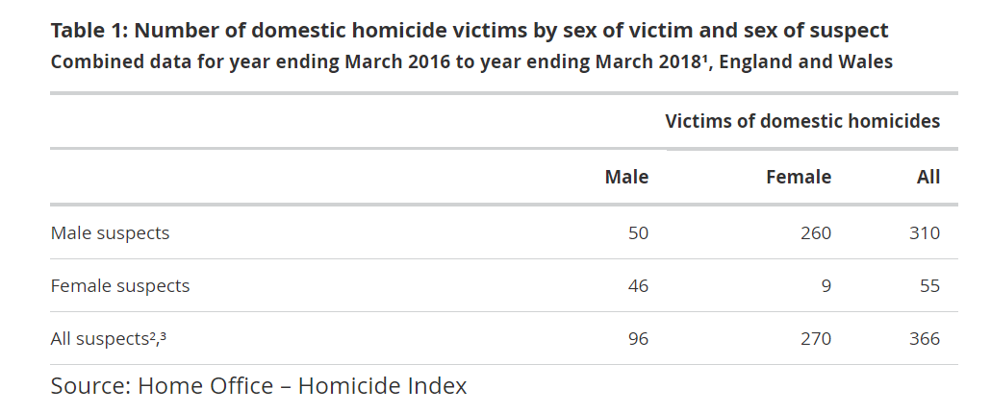
Figure 4: UK domestic homicide rates by gender

Figure 5: Cambridgeshire and Peterborough IDVA Service by Gender

Figure 6: Local support service referrals by gender

2.4.1 Gender as a barrier
Gender was relatively well recorded across agencies. The under-representation of men, non-binary and transgender persons recorded is an indication that gender could be a barrier to accessing support services. Moreover, gender may be being assumed and not asked which could lead to inaccuracies in the datasets.
2.4.2 National Evidence
- Of all callers to the National Domestic Abuse helpline in the year ending March 2020, 93% were identified as female.
- The data on clients accessing IDVA services for the year ending March 2020 shows that 93% were women.
- Although 80% of transgender individuals have experienced some form of abusive behaviour from a partner or ex-partner, only 60% have recognised the behaviour as domestic abuse.
- Disclosure is still lacking due to ongoing homophobia and transphobia in modern day society, including from professionals such as DA specific agencies and the police.
- Independent Choices in Manchester offers a specialist LGBT service including an IDVA service for LGBT+ people who are experiencing domestic abuse which highlights that LGBT+ victims of violence and abuse often benefit from access to specialist LGBT+ services. Victims and survivors don’t have to explain who they are and can have trust and confidence in the service.
More details on the LGBT+ community will be discussed under sexual identity.
  - 2.5 Marital Status
KEY FINDINGS
- Most victims using support services in Cambridgeshire and Peterborough were separated.
- Marital Status was not recorded at all in some agencies and there was a large proportion of unknowns for those who did provide data.
Figure 7: Local support service referrals by marital status

2.4.1 National Evidence
ONS figures from year ending 2020 highlight that 16.4% of domestic abuse victims were separated and marriage was the lowest category with 3%.
  - 2.6 Sexual Identity
KEY FINDINGS
- Sexual identity is recorded very poorly across local support agencies.
- Due to the large number of unknowns, there is no reliable analysis to be drawn from the dataset.
- Only 0.4% of clients using the IDVA service in Cambridgeshire and Peterborough were identified as part of the LGBT community which is likely to reflect under-recording.
2.6.1 Sexual Identity as a barrier
As mentioned in the above section on gender, LGBT+ communities still face additional barriers when accessing services, as well as experiencing discrimination in wider society.
2.6.2 National Evidence
- There are no official ONS statistics reported about experiences of lesbian, gay, bisexual and trans people with domestic violence and abuse that would establish a UK-wide picture.
- Evidence suggests LGBT+ people experience equal or even higher prevalence of domestic violence and abuse, compared to heterosexual women.
- Despite high levels, LGBT+ survivors are disproportionally unrepresented in specialist domestic abuse services, For instance, less than 2% of all domestic abuse survivors accessing IDVA services in England and Wales, identify as LGBT+ and 78% of gay and bisexual men and 80% of gay and bisexual women who have experienced domestic violence have never reported incidents to the police.
Safelives published a blog written by Dr Jasna Magic, Galop’s LGBT domestic abuse research and policy offer. Galop are the LGBT+ anti-violence charity and run the national domestic helpline for LGBT+ people. The blog details the reasons LGBT+ groups continue to be underrepresented including:
- Reluctancy to disclose their relationships and identity with non-LGBT+ organisations
- Belief that services are ‘not for them’ and fear and/or anticipate being misunderstood or discriminated against by services.
- Belief that service provision is prejudiced and may result in concerns around disclosure of sexual orientation and/or gender identity.
- Reluctancy to report and engage with the police and are not likely to opt for cooperation or criminal justice.
- Failure to recognise and acknowledge their experience as abuse due to the narrative around ‘weaker heterosexual cis woman abused by a physically stronger man’.
- Fear of rejection and denial from their peers.
- Lack of knowledge and understanding around the spectrum of gender identities and sexualities and visibility and representation of LGBT+ issues within service delivery and provision.
- Services not appearing competent and/or welcoming to adequately address the needs of LGBT+ survivors and encourage them to come forward.
- Services lack appropriate interventions and outreach to LGBT+ victims.
- Services might also lack established partnerships with LGBT+ organisations and specialist services, which may result in lack of appropriate referral pathways and lack of knowledge on the available support and resources.
- Specifically relating to both trans women’s and trans men’s experiences, services may continue to be offered or declined based on the victim’s sex assigned at birth rather than their gender identity.
  - 2.7 Disability
KEY FINDINGS
- Data on disability was recorded poorly across the agencies who provided data. Cambridgeshire Constabulary only record if there is a disability and not if it is unknown or no disability. There was 68 recorded in 2020/21 out of the 7588 victims of DA recorded, this account for less than 1%.
- The IDVA service, recorded that 468/1173 had a disability, accounting for 40% of the clients. The most common type of disability was mental health (431 clients).
- Only 5% of clients referred to the MARAC process in Cambridgeshire and Peterborough were recorded as having a disability.
- For the Cambridge Women’s Aid outreach service, out of those recorded as having a disability, 23% were recorded as having multiple disabilities. Recording where a client has multiple disability is good practice as it will provide services with a better understanding of their needs when it comes to safe accommodation.
  - 2.7.1 National Evidence
- In the year ending March 2020, around 1 in 7 (14.3%) disabled people aged 16-59 years experienced any form of domestic abuse in the last year in England and Wales, which is significantly higher when compared with 1 in 20 (5.1%) for non-disabled people of the same age.
- Women and men with long standing illness or disability are three times as likely to experience some form of disability than women and men with no long-standing illness or disability.
- Disabled victims of domestic abuse also suffer more severe and more frequent abuse over longer periods of time than non-disabled victims.
- SafeLives’ data reveals that disabled victims typically endure abuse for an average of 3.3 years before accessing support, compared to 2.3 years for non-disabled victims. Even after receiving support, disabled victims were 8% more likely than non-disabled victims to continue to experience abuse.
- SafeLives highlights that abuse experienced by a person with a disability is often directly linked to this disability and perpetrated by the individuals they are most dependent on for care, such as intimae partners or family members.

- National data shows that disabled victims are much more likely to be suffering abuse from a current partner (31%) than non-disabled (18%).
- Safe lives highlight that of the 16,000 disabled people experiencing high risk domestic abuse, an estimated of 13,600 either are not supported by a MARAC or their disability is not identified in the MARAC process.
- Safe lives emphasised that in 2015/16 0 out of 925 referrals of disabled victims to domestic abuse services were from adult safeguarding despite clear legal frameworks requiring local authorities to safeguard vulnerable adults.
2.7.2 Disability as a barrier
The 2018 report A Refuge for All (Shaping Our Lives) found that:
- DA services generally define ‘accessible’ as meaning accessible for wheelchair users which excludes a large part of the disabled community with different needs.
- There is a lack of information in alternative formats, especially considering people that cannot read.
- Services are often too far away for people with disabilities to travel to easily.
- A lack of appropriate accommodation for women with disabilities leads to disabled survivors being unable to leave their abuser.
Locally Cambridgeshire Deaf Association provide specific support for victims of domestic abuse including group programmes and trained IDVAs. Data from Cambridgeshire Deaf Association can be found on page 22.
  - 2.8 Ethnicity
KEY FINDINGS
- Ethnicity was poorly recorded across the datasets and was unknown in around 1/5 referrals.
- Future needs assessment guidance documents should use same ethnicity categories as UK Census to avoid inconsistencies.
- It is possible that agencies have put unknowns into the ‘other’ category which has skewed the results for ‘other ethnicities’.
- It is important to distinguish between ethnicity and national identity/ nationality when recording data. Ethnicity is the state describing the heritage and ancestry whereas nationality described the status of belonging to a particular nation, which could be the country of birth or where the person holds citizenship.
- Cambridgeshire and Peterborough have significant gypsy/roma/traveller communities, but they are under-represented in the data. Data from local organisation One Voice for Travellers can be found on page 22.
The table below sets out population by ethnicity taken from the 2011 Census for the East of England, Cambridgeshire and Peterborough Combined. It then details the ethnicity breakdown for clients using support services in Cambridgeshire and Peterborough. Ethnicity was unknown in around 1/5 of the datasets provided for this need’s assessment. The percentages below are calculated not including the unknowns.
Figure 8: Ethnicity of clients using support services
Ethnicity | East of England | Cambridgeshire & Peterborough Combined | Victims of DA accessing Support Services Cambridgeshire/ Peterborough
White English/Welsh/Scottish/Northern Irish/ British | 85.3% | 90.3% | 81%
White Other | 4.5% | 7.9% | 1.2%
Asian/Asian British | 4.8% | 5.9% | 5%
Black/African/Caribbean/Black British | 2% | 1.3% | 2.2%
Other | 0.5% | 0.6% | 5.3%
Mixed/multiple ethnic groups | 1.9% | 2% | 1.6%
Gypsy/Roma/Traveller | 0.1% | 0.3% | 0.09%
White Irish | 1% | 0.8%
White European |  |  | 3.9%

  - 2.8.1 National Evidence
Black and Asian women are disproportionately at more risk of being killed by a domestic abuser, despite being as likely as any other racialised minority group to experience domestic abuse overall. In turn this means there could be a greater need for Black and Asian women to seek refuge due to their increased risk of becoming victim to a domestic homicide.
Safelives emphasise that victims from BAME communities typically suffer abuse for 1.5 times longer before getting help than those who identity as White, British or Irish. There are further inequalities such as- BAME women are disproportionately impacted by specific forms of violence against women and girls- such as forced marriage and ‘honour based violence’ in the context of DA, they are three times more likely to be abused by multiple perpetrators, a quarter of BAME victims say they need the aid of an interpreter to communicate effectively and 1 in 5 have no recourse to public funds. This can be a significant obstacle to accessing safe accommodation.

  - 2.9 National Identity
KEY FINDINGS
Most agencies do not gather information on national identity.
The table below highlights the rough percentage of UK and non-UK nationals living in Cambridgeshire, Peterborough, and the East of England captured in the 2011 Census.
Figure 9: National identities East of England, Cambridgeshire, and Peterborough July 2019-June 2020
 | East of England | Cambridgeshire | Peterborough
UK-Nationals | 87.7% | 84.7% | 77.7%
Non-UK Nationals | 12.1% | 15.1% | 21.8%
European Union | 5.6% | 6.3% | 12.9%
A8 Countries | 2.3% | 2.3% | 8.9%

The table below shows the top 5 nationalities for IDVA referrals and MARAC cases not including British. (There were 83 and 43 unknowns)
Figure 10: IDVA and MARAC referrals by nationality
MARAC cases
Lithuanian- 39
Polish- 37
Latvian- 21
Pakistani- 20
Romanian- 14

IDVA Referrals
Polish- 151
Lithuanian- 140
Latvian- 48
Pakistani- 31
Romanian- 21

The A8 IDVAs who work with clients from Estonia, Latvia, Lithuania, Poland, Czech Republic, Slovakia, Hungary, and Slovenia, will work with victims at all risk levels whereas other IDVA’s who work with all other nationalities only take referrals for high risk victims. This may impact the dataset for IDVA Referrals to some extent.
However, the nationalities of victims across the IDVA and MARAC datasets broadly matches the Cambridgeshire Research Group report which stated that the top 5 nationalities for victims across the local area were – British, Polish, Lithuanian, Romanian and Portuguese.

  - 2.10 Household Structure & Children
KEY FINDINGS
- Household structure and children of victims of DA were not recorded well across the agencies.
- A larger proportion of IDVA clients did have children compared to those who did not.
- Clients using the IDVA service who were recorded as having children were most likely to have one or two children.
- It is now even more important to accurately record the number of children linked to a DA case, as those who witness DA are also considered victims of DA under the new DA Bill.
Figure 11: Cambridgeshire and Peterborough IDVA service- Clients and their children

Figure 12: Cambridgeshire and Peterborough IDVA Service- Number of children per client

2.8.1 DA and Children’s Referrals
There was a total of 179 children referrals made to Children’s Social Care across Cambridgeshire and Peterborough in 2020/21 where domestic abuse was the primary concern. The table below highlights the referral outcomes.
Figure 13: DA Children's Referrals (DA primary factor) outcomes
Row Labels | Count of Case Number
Child and Family Assessment | 148
Child Protection Transfer from other LA - | 1
Provision of Advice and Information (NFA) | 28
Referral to Early Help | 6
Strategy Discussion | 33
Grand Total | 216

These figures only record cases where domestic abuse has been the primary concern on a safeguarding children’s referral. Data is not available for 2020/21 recording referrals where domestic abuse is a secondary factor but data from previous years indicates the number is considerably higher. Data from organisations working with children that received funding from the Office of the Police & Crime Commissioner in 2020 can be found on page 22.

  - 2.11 Occupation
KEY FINDINGS
- For those who provided occupation data, it was not recorded in over 1/3 cases.
- The largest group out of the available data (not including unknowns) was unemployed. However, ‘unemployed’ does not necessarily mean this person is in receipt of benefits or from lower socioeconomic groups as clients who were looking after their children may have been counted as unemployed.
- A Local victim needs assessment for victims of all crime types indicates that victimisation is generally higher among those who are unemployed .

  - Languages
KEY FINDINGS
- After English, Lithuanian, Polish and Latvian were the most common languages spoken by clients using the IDVA service or who were referred to MARAC. (It is important to note that there are specialist A8 IDVAs who work specifically with clients from these countries).
- Many clients will not have trust in public services such as housing and police due to negative experience in their country of origin. Ensuring there are professionals working in the field of DA who speak the native language of the victim is important as a language barrier can lead to misunderstandings around the risk of abuse and support available.
The table below highlights the top 5 spoken after English for MARAC referrals and IDVA clients.
Figure 14: Languages spoken- IDVA and MARAC Data
MARAC referrals
Lithuanian- 33
Polish-32
Latvian- 18
Romanian- 12
Portuguese- 6
IDVA clients
Lithuanian- 100
Polish- 97
Latvian- 27
Urdu- 7
Romanian- 7

Additional Resource during 2021

During 2020 the Government announced a range of additional funding opportunities for domestic abuse and sexual violence support services:

- Covid-19 Extraordinary Ministry of Justice Funding for Domestic Abuse and Sexual Violence Support Services – through which the Office of the Police and Crime Commissioner in partnership with the local authority secured an additional £380k for local services. This was awarded to core and emerging grass roots specialist organisations enabling seldom heard communities to access bespoke services.
- Funding from the Home Office for three additional ISVAs for two years.

As well as successful bids for the funding from Cambridge Women’s Aid, Refuge and Cambridge & Peterborough Rape Crisis, the organisations below were all awarded funding through the Ministry of Justice Covid 19 Extraordinary fund.

Cambridgeshire Deaf Association
- Provided support to 26 deaf victims of domestic abuse, including three male victims. 21 victims had additional needs, requiring support with areas including courts, finances, housing and child protection procedures. Seven clients were supported to move to a safer location. The service continued to support victims face to face where this was essential and their needs could not be met remotely due to their communication requirements.

Choices
- Adapted their support during the pandemic to offer victims of childhood sexual abuse a short-term stabilisation service consisting of a six-session programme of psychoeducation, stabilisation, and resourcing. They received 85 referrals and were able to offer support to 49 victims.

NSPCC
- Funding supported 43 young victims of crime, including rape, sexual assault, online grooming and domestic violence to receive therapy and support to help them recover from their trauma. Funding helped to provide resources so that children could have their own equipment to use during sessions as this could not be accessed from the centre in the usual way during the pandemic.

One Voice 4 Travellers
- 82 victims of domestic abuse within the Gypsy, Romany and Traveller community were supported. Practical and emotional support was delivered using a variety of different methods including phone, WhatsApp, Facebook and Zoom to ensure that victims could still be supported during the pandemic. Victim’s reported that perpetrators were becoming more stressed as a result of being confined in their home environments and being unable to work during lockdown, with victim’s who had previously been supported by the charity getting back in touch for reassurance and support.

The Meadows Children and Family Wing
- The Meadows provided support to 201 female victims of domestic abuse and their families, the service adapted the support offered and the Freedom Programme was delivered virtually to 18 women who were supported through phone calls after each session. WhatsApp groups were set up to provide the women with peer support and to help combat loneliness. Over 480 food boxes were provided to families who were struggling financially due to the pandemic.

Embrace – Child Victims of Crime
- 163 young victims of domestic abuse, bullying, hate crime or sexual abuse were supported to access therapeutic support, 53 of these victims were aged 12 years or under. Support was adapted to be provided in online virtual rooms along with phone-based support and occasional ‘walk and talks’ and even using a camper van in a Covid secure way. 20 young people were also provided with tablets to support their home learning.

Family Action
- Specialist workers from Family Action worked with 301 young victims of crime and their families, over half of whom were aged 12 years and under, providing 1-1 support and onward referral and signposting to a wide range of local agencies. 89 per cent of the young people said that they felt more empowered as a result of the support they had received.

Incidents and Homicides
  - 3.1 Incidents
Figure 15: DA Incident Cambridgeshire Constabulary
Cambridgeshire Constabulary were able to provide numbers of DA incidents recorded over the past 3 years. The table below sets out the number of incidents closed as a domestic abuse incident within the three time periods, regardless of whether it resulted in a crime or not.
Constabulary, number of domestic incidents | 2018/19 | 2019/20 | 2020/21
DA Incidents Reported: | 13,397 | 14,116 | 14,804

Figure 16: ONS Domestic Abuse Data Tool 2020- Incidents in Cambridgeshire and comparable areas
ONS data below shows the number of crimes recorded in the year ending March 2020 plus the number of incidents which were closed as domestic incidents but did not result in a crime being recorded.
There were 10,852 domestic abuse crimes plus 7,200 incidents which did not result in a crime being recorded equalling 18,052. More than one crime can be recorded from one incident, e.g. crime of harassment and a crime of assault can be recorded from the same incident.
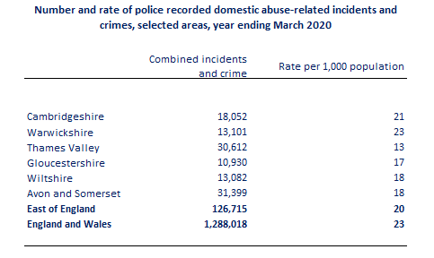

There was not a significant change in the prevalence of DA experienced in the year ending March 2020 compared to the year ending March 2019. Police recorded 1,288,018 incidents, of these 758,941 were recorded as DA Abuse related crimes which is a 9% increase from the previous year. This may reflect improved recording by police and increased reporting by victims.

3.1.1 Incidents and Covid-19
Although police recorded crime data shows an increase in offences flagged as DA abuse related during covid-19 there has been a general trend in this direction over the last couple of years and therefore this can’t be directly correlated to covid-19.
However, The National Domestic Abuse Helpline saw a 65% increase in calls/contacts and a 700% increase in website visits in April-June, compared to January-March 2020. Moreover, Support services have highlighted increased cyberstalking since the start of the Covid-pandemic.
General increase in demand for DA victim services, particularly the demand on helplines as lockdown periods eased, may not necessarily indicate rise in victims but instead an increase in severity of abuse being experienced, and a lack of available coping mechanisms such as the ability to leave the home to escape the abuse, or attend counselling.
Also, there were 2324 referrals to the IDVA Services for domestic abuse. IDVA referrals deal with high risk victims of DA. The referral rates highlight an increase by 18% in 2020/21 compared to the previous year with increases following the first and second lockdowns. Given the majority of IDVA referrals are from police – there appears to be an increase in the severity or risk when coming to police, and potentially, where there was not so much risk, the police were not being called.
    - Homicides
There were 357 domestic homicides recorded by police in England and Wales in the three-year period between year ending March 2017 and March 2019, which represents 19% of all homicides when 16 years old or older.
In year ending 2020, 81 females were killed in domestic homicide In the context of domestic abuse (current or former intimate partner, or family member), , which is almost half of adult female homicide victims (46%). Males are much less likely to be the victim of domestic homicide, with only 7% of male’s homicides being domestic in the latest year, totalling 33.
Figure 17: Suspects of female and male homicides
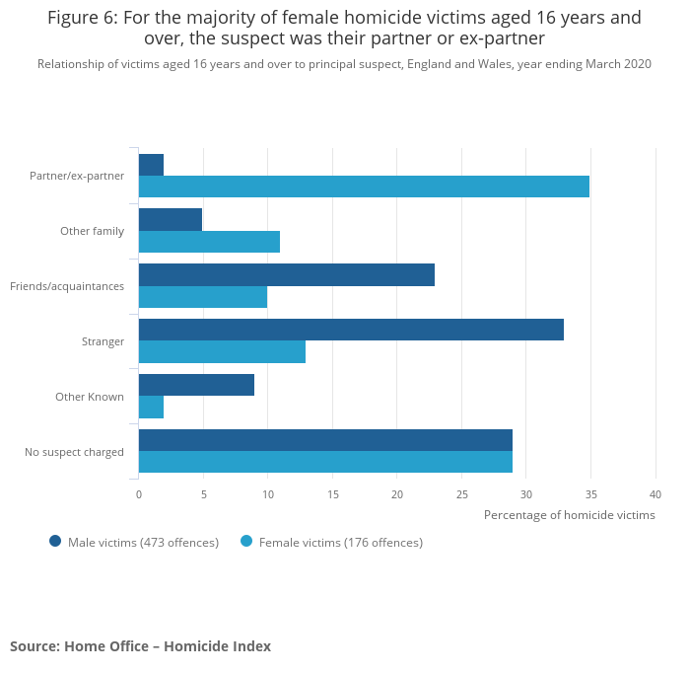

Figure 18: Cambridgeshire and Peterborough Domestic Homicide and Suicide rates
 | 2018/19 |  | 2019/20 |  | 2020/21
 | Male | Female | Male | Female | Male | Female
Number of Domestic Homicide Reviews- Homicide | 1 (self-defence/ male perpetrator) | 1 | 0 | 3 | 1 | 3
Number of Domestic Homicide Reviews- Suicide | 2 (One safeguarding adult review) | 2 (One safeguarding adult review) | 0 | 0 | 1 | 2

Domestic Abuse by area

  - 4.1 DA by districts
The rate of victimisation in Cambridgeshire and Peterborough in 2019 was an average of 43 victims per 1,000 population. Victimisation rates were higher in the urban areas of Cambridge City and City of Peterborough than they were in South Cambridgeshire where it was recorded as 31 victims per 1,000 population. Higher rates of victimisation also correlate with areas of higher unemployment levels. The map below shows the rate of victimisation by LSOA and illustrates the variation at a small area level with generally higher rates in the north of the area.

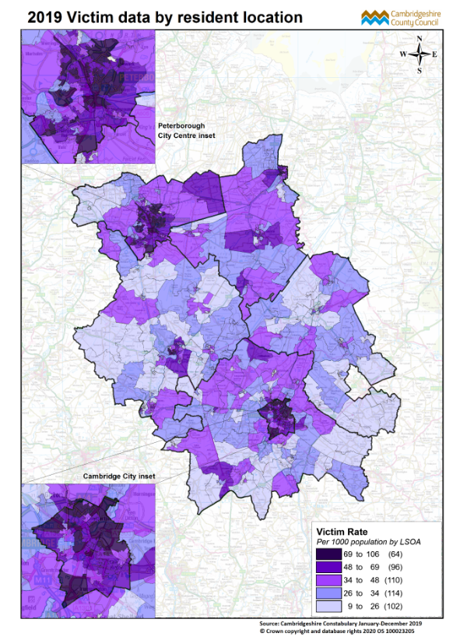

This broadly reflects the areas of higher referrals for DA. In the map below the darker red represents areas of higher referral and although Peterborough is not on the map it would also be dark red.

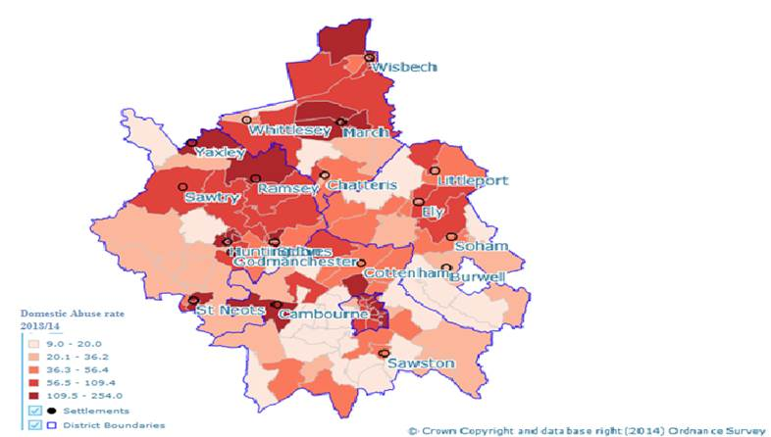
It should be noted that one reason DA may appear higher in urban areas may be down to the fact that victims are living in a higher populated area and in closer proximity to their neighbours who may call in an incident. This contrasts with those that live in the suburbs or more rural areas.
Figure 19: IDVA referrals by Area 2019/20

Figure 20: MARAC referral numbers by area
The table below highlights the MARAC referral numbers for 2020/21 by area and considers the population size of the area to emphasise how many high-risk victims there are per 1,000 people.
Area | Referral Numbers | Population Size 2019/20 | Victims per 1,000 people
Cambridgeshire A8 | 45 | 15,000 | 3
Peterborough A8 | 47 | 18,000 | 2.6
Peterborough | 331 | 202,000 | 1.6
Cambridge City | 166 | 122,000 | 1.3
Huntingdonshire | 183 | 177,000 | 1
Cambridgeshire Fenland | 101 | 101, 000 | 1
Cambridgeshire East | 76 | 90,000 | 0.8
Cambridgeshire South | 104 | 159000 | 0.7

  - 4.2 Rural Areas
In rural communities it can be harder for residents to seek and access support services. They may also be more isolated regarding proximity to the wider public and therefore it is less likely that they will be referred into services by someone else, e.g. a neighbour. This can make victims in rural communities more vulnerable due to accessibility. A recent research project from the National Rural Crime Network on DA had several findings including that abuse lasts 25% longer in rural areas, the more rural the location the higher the risk and services are less easily accessed.
‘The needs in Fenland are more complex compared with the rest of the area. More clients present with mental health problems and substance misuse. Fenland is an area of deprivation, in a rural location with reduced access to support for the above issues.’ (Refuge, 2021)
‘DA is more prevalent in our three main market towns, Ely, Littleport and Soham. East Cambs is a rural area and there could be gaps where we are not reaching those more isolated. We have a high number of Eastern Europeans that live in the Soham/Burwell area and this is a hard group to get any engagement.’ (East Cambridgeshire Housing)

  - The figure below shows the proportion of the populations of Cambridgeshire and Peterborough in areas designated rural at the time of the 2011 Census. An update to this data set will be available from the 2021 census in due course.
Figure 21: Proportion of Cambridgeshire population and Peterborough population in Rural areas (Census 2011)
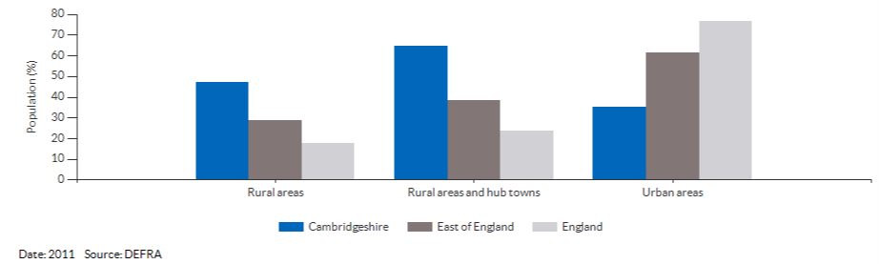
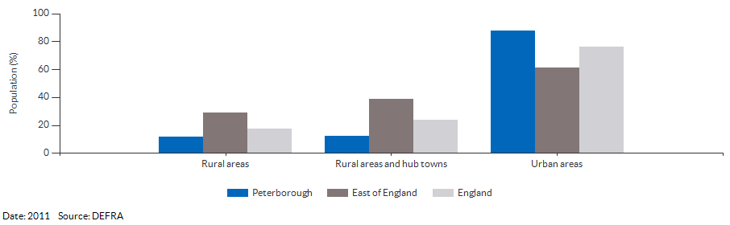

  - 4.2 Ethnic Minorities and Migrant Workers
Migrant workers can be particularly vulnerable to domestic abuse for a number of reasons which may include; limited knowledge of UK law and support services, language barriers, reluctance to engage with agencies/services due to distrust and concerns over the security of immigration status (particularly where immigration status is linked to their partner), migrant cultural issues and financial challenges which limit security and options.
If clients are worried about their legal status they are less likely to reach out to support services, this adds to the abusers’ control over them. A study by Imkaan (2012) of 183 women who accessed support from 10 different VAWG organisation found that 92% had experienced threats of deportation from the perpetrator. Two domestic homicide reviews in Cambridgeshire have cited some of the above issues as relevant factors.
In Cambridgeshire and Peterborough in addition to the general support available for victims of domestic abuse, tailored support is also available through the Specialist Victim and Witness Care Coordinators for victims of migrant exploitation (modern day slavery) who pick up a number of domestic abuse cases where it is linked to exploitation and also through the A8 IDVAs (Independent Domestic Violence Advisors) who work with victims of domestic abuse from the Eastern European ‘A8’ countries at all risk levels.
Following from several domestic homicides within the A8 communities, there has been a growing emphasis on the increased support need for A8 victims. In Wisbech and Fenland, where there is a high proportion of Eastern European people, there is the Central and Eastern European Homelessness project being run by Change Live Grow (CGL). These additional sources of support can ease pressure on the IDVA dealing with this case leading to a collaborative approach with another agency in turn leading to better outcomes.
  - 4.3 Marginalised Communities
Discussions with professionals has highlighted some of the barriers which can exist for marginalised communities. One of the IDVA’s works with clients across Fenland, many of whom have never left the vicinity of Fenland. It is an interesting demographic which is isolated from other areas, there are lots of traveller communities and eastern European communities. They expressed the difficulties in language barriers when working with clients, the deprivation, the prevalence of drugs and alcohol dependency and moreover the culture differences. They said:
‘Cultural barriers can act as a significant obstacle in working with traveller communities. Moreover, it is hard to break the ongoing cycle of Domestic Abuse where many victims and perpetrators have never experienced healthy relationships and often grown up in abusive households. Moreover, in areas of higher deprivation, victims will often be surrounded by friends with alcohol and drug issues, but they will struggle to move away from this area when it is all they know.’ (IDVA for Fenland Area)
Clients who do not originate from the UK may not have trust in public services such as housing and police due to negative experience in their country of origin. Sources emphasise that there can often be professionals in the system working with victims of DA that have discriminatory attitudes towards these clients and incorrect knowledge of immigration rights. Moreover, there is a lack of professionals who speak the native language and who understand the potential cultural differences which can lead to misunderstandings around the risk of abuse.
  - 4.4 Out of Area referrals
Cambridge City Council housing were able to give an indication of where domestic abuse related referrals come from by looking at the housing register data. For those applicants who have applied to join the housing register over the past 3 years and have stated that they have a support need related to DA there are about 200 applicants.
Out of these 200, 134 were applying from within Cambridge. The remaining 66 applicants specify an address outside of Cambridge, most of which are still in the East of England, with 19 from Cambridgeshire and 4 from Peterborough. The other places include a range of locations across the UK.
Overall, this highlights that a significant proportion will present from within the district of City, seeking rehousing within the district, despite the increased risk that this may pose. This matches with information from East Cambs District Council who stated that-
‘We have most of our referrals from other LA's we have a high number from and West Suffolk and Fenland- they will approach us as advised by either Housing or Women's aid.’ (East Cambridgeshire Housing)
Moreover, South Cambs district council stated that-
‘We do get approaches from DA victims out of area but very few, most approaches are from people within the district or within out Cambridgeshire subregion who do not want to move far… We do not tend to get many LA referrals for people who want to move into our district due to DA. Most of the applications from those out of the area are made directly to us by the applicant.’
The victims placed in refuge would be considered high risk and therefore most referrals come from out of area as it wouldn’t be deemed safe to stay in their current location. In 2020/21 there were 5/90 clients from within the area who were supported in refuge accommodation, the rest were from out of area. Those who are within the area will have moved across the county in order to ensure safety. The chart below emphasis where clients given refuge accommodation in 2020/21 fled from. The majority fled from locations also in the East of England.
Figure 22: Referral areas for refuge accommodation

Refuge Accommodation & the Bobby Scheme

  - 5.1 Introduction
Data has been provided by the four refuges in Cambridgeshire and Peterborough, run by Refuge and Women’s Aid for the year 2020/21. Refuges in Cambridgeshire and Peterborough housed a total of 90 victims of DA during 2020/21 (not including their children). Refuge accepted 40 new referrals across their two refuges in Cambridgeshire, Peterborough Women’s Aid accepted 15 and Cambridge Women’s Aid accepted 35.
The most common reasons for being denied access to refuge are complex needs including substance misuse and mental health needs, no recourse to public funds, client being from the same area/ connected to the area or client not supporting the move to Cambridgeshire/ Peterborough. The average stay in refuge can range from a few weeks to over a year. The most common length of stay across all the refuges in the area appears to sit within the 0-6months bracket.
The Bobby Scheme, who instal security devices at victims’ homes to enable families to remain safe in their homes supported 331 homes in 2020/21. They work across Cambridgeshire and Peterborough
Figure 23: Bobby Scheme feedback from clients 2020/21
The below charts indicate some of the positive outcomes that users of the Bobby Scheme reported-they asked for feedback from around half of those using the service.

  - 5.2 Age
KEY FINDINGS
- Most people staying in refuge were aged between 25-35 (26-35 for Cambridge WA).
- There was nobody aged 65 or over who was successfully referred into refuge accommodation.

There are clearly barriers for older victims to access refuge services which may come down to personal choice of victims not wanting to stay in refuge accommodation or refuge accommodation not being suitable to their needs. It could also be attributed to the fact that older people are less likely to seek support in the first place.
As highlighted previously in the report, older victims are less likely to attempt to leave in the year before accessing help and are more likely to be living with the perpetrator after getting support. Also, older victims are significantly more likely to have a disability- for a third, this is physical (34%). This could again create obstacles when trying to flee DA and access safe accommodation.
Children are also welcome in the refuge but having male teenage children could be a barrier since refuge accommodation across Cambridgeshire and Peterborough is female only and although younger male children may be given a place, older male children may not. This will be decided on a case-to-case basis.
  - 5.3 Gender
- Female clients have a higher need for emergency accommodation due to the higher risk nature of the abuse, e.g. Most victims of domestic homicide between March 2016-March 2018 were female (74%).
- There is a barrier for clients with teenage boys accessing refuge accommodation.
- There is a lack of suitable emergency accommodation for male victims.
- There is evidence that trans-gender/trans-sexual people face barriers when gaining support and accessing safe accommodation as highlighted previously in the report.
The refuges in Cambridgeshire and Peterborough only place female clients. In Peterborough Women’s Aid boys 13 years old or over are not able to access refuge accommodation.
There are only 33 organisations who have refuge/ safe houses places for men and there are none are in the East of England.
Furthermore, as mentioned in the report previously, trans-gender/trans-sexual people are under-represented in data relating to support services and the obstacles and barriers to gaining support will apply equally to accessing safe accommodation.
  - 5.4 Sexual Identity
There were 2% of clients across all the refuges who identified as gay/lesbian. Although, there are no restrictions on clients of any sexual identity to enter refuge, there is still potential barriers because LGBT clients are less likely to be accessing support services in the first place.
  - 5.5 Housing
KEY FINDINGS
- Before being placed in Women’s Aid accommodation, clients from 2020/21 were most likely to have lived in social housing/ LA General needs housing.
The chart below describes where the 50 clients that are now staying in Women’s Aid accommodation were staying previously.
Figure 24: Client housing type before refuge

  - 5.6 Family
KEY FINDINGS
- Most clients staying in refuge accommodation from successful referrals in 2020/21 had children.
- The Bobby Scheme protected 526 children under the age of 18 through installation of security devices.
Figure 25: Clients staying in refuge- number of children (those listed as pregnant may also have other children)

  - 5.7 Ethnicity
Figure 26: Ethnicities of those staying in refuge
The ethnicities of those staying in refuge is the following-
Ethnicity | East of England | Cambridgeshire & Peterborough Combined | Victims of DA accessing Support Services Cambridgeshire/ Peterborough | Clients in refuge accommodation
White English/Welsh/Scottish/Northern Irish/ British | 85.3% | 90.3% | 81% | 63%
White Other | 4.5% | 7.9% | 1.2% | 2%
Asian/Asian British | 4.8% | 5.9% | 5% | 6%
Black/African/Caribbean/Black British | 2% | 1.3% | 2.2% | 2%
Other | 0.5% | 0.6% | 5.3% | 9%
Mixed/multiple ethnic groups | 1.9% | 2% | 1.6% | 4%
Gypsy/Roma/Traveller | 0.1% | 0.3% | 0.09% | 3%
White Irish | 1% | 0.8% |  | 1%
White European |  |  | 3.9% | 2%
European Union |  |  |  | 4%

  - 5.8 Immigration Status
If clients have uncertain legal status, they may not be entitled to public funds. If a victim can’t pay for refuge or access public funds to finance accommodation, they cannot be placed in refuge accommodation. Therefore, no recourse to public funds is a barrier to accessing safe accommodation. If clients have children, then social services may finance refuge accommodation.
Clients can apply for their Destitution Domestic Violence (DDV) concession which allows them to stay in the UK and access public funds. To qualify for the concession, you must be a spouse/ come to the UK for the purpose of marriage or already be married. You can apply outside these rules, but it is up to the Home Office to decide this. It can several months for the concession to be processed. However, Refuges in this area may work with clients who are waiting for their Destitution Domestic Violence (DDV) concession to come through on a case by case basis.
  - 5.9 Language
There were 6% of clients staying in refuge who needed a translator/ interpreter. There are provisions within the three refuges to assist those who do not speak English when helping the clients with official DA support.
  - 5.10 Culture and Faith
In Peterborough refuge, 3 out of 15 clients in 2020/21 were unable to stay with male children aged 13-18 due to their culture/faith. This links back to the barrier that clients with teenage male children may face.
  - 5.11 Employment
KEY FINDINGS
- Most successful referrals from 2020/21 were unemployed victims- 92%.
- Employment can be a barrier to accessing refuge accommodation due to the financial implication of paying for refuge and due to the practicality of having to leave the area where your job is situated.
There could be several reasons why employed people are less likely to use refuge services including the fact that victimisation is generally more prevalent among unemployed people as highlighted in the previous section. They may also have increased options due to employment and potentially less reliance on the abusive partner.
This doesn’t mean to say that employed people are not at risk of domestic abuse. An employed person with a stable income would potentially have more options when faced with the risk of abuse (e.g. able to find property independently). Moreover, before Covid-19 and the option to work remotely, clients fleeing DA would most likely not be able to keep their job since they would be leaving the area to access safe accommodation. Victims would need to leave employment if it was too far from safe accommodation or too high risk due to proximity to perpetrator. The Employers Initiative on Domestic Abuse is a national campaign to encourage employers to support employees experiencing DA and encouraging local employers to sign up to EIDA would be useful.
In addition, employment can be a barrier to accessing refuge accommodation as if someone is earning a wage rather than claiming benefits, the rent for refuge may become too expensive. There is a case example explored in the section below under survivor feedback which highlights the barrier of employment and how it can disadvantage survivors.
  - 5.12 Disability/ Health
KEY FINDINGS
- 34% of successful referrals from 2020/21 were recorded as having a disability. This does not include children staying in the refuge who may have a disability.
- In the Peterborough WA refuge, 60% of clients self-referred themselves as having a mental health issue.
- Refuge highlighted that complex mental health needs or substance misuse issues could be a barrier to accessing safe accommodation.
- The refuge in Peterborough does not have wheelchair access and the accommodation itself can’t be adjusted as to accommodate this. Therefore, having a physical disability would act as an obstacle for accessing this refuge. The other local refuges all have at least one wheelchair accessible room.
Figure 27: Client disability type in refuge accommodation
Out of those across all three refuges who were recorded as having a disability, the chart below gives a breakdown of the type of disabilities.

  - 5.13 Additional Support Needs
KEY FINDINGS
- The most common additional support needs that were recorded by refuge accommodations were mental health and financial support/ no recourse to public funds combined.
- Cambridge WA identified when clients had more than one vulnerability, this was the case for 14% of clients.
- All refuges should record when clients have more than one vulnerability as to understand how many clients in refuge accommodation have complex and varied support needs.
Figure 28: Additional Vulnerabilities of clients in refuge accommodation

Housing options in Cambridgeshire & Peterborough (beyond emergency accommodation)

  - 6.1 Housing
Across Cambridgeshire and Peterborough, the district council housing teams (alongside housing associations) will assist victims of DA to move into permanent accommodation.
The district councils who have provided us with data relating to victims of DA who are using their services include-
- East Cambridgeshire
- Fenland
- South Cambridgeshire
- Cambridge City
- Peterborough
- Huntingdon
The data analysed in this section is in relation to 2020/21.
  - 6.2 Age
KEY HEADLINES
- The most common age group of victims on housing register due to DA in the numerous districts across Cambridgeshire and Peterborough was 25-34 yrs.
Figure 29: DA Victims on housing register 2020/21 by Age

Figure 30: DA victims on housing register 2020/21 by Age in Huntingdon

Again, as highlighted previously in the report there is under-representation as the age increases with a significantly low number of elderly people using housing services. This supports evidence that older people are likely to stay in abusive relationships longer.
  - 6.3 Gender
- The large majority of those accessing housing services at the district councils were female.
Figure 31: Victims of DA on housing register by Gender

  - 6.4 Accommodation at time of approach
KEY FINDINGS
- The most common accommodation types on approach were living with family (30%) and refuge (14%).
- There were 17% who came under the category of homeless, no fixed abode or rough sleeping.
Figure 32: Accommodation at time of approach for Victims of DA on housing register

  - 6.5 Sexual Identity
KEY FINDINGS
- There were a significant number of people who preferred not to reveal their sexual identity.
- As signified earlier in the report there is a very small percentage of LGB people accessing support services, including housing.
Figure 33: Victims of DA on housing register by Sexual Identity

  - 6.6 Disability
- The most common disability recorded across the district councils in 2020 was ‘history of mental health problems.
- It would be helpful to record which victims had multiple disabilities.

Figure 34: Disability type recorded for victims of DA on Housing Register

  - 6.7 Ethnic Group
Figure 35: Ethnicities of victims on housing register in East Cambs, South Cambs, Cambridge City, Fenland, Huntingdon
Ethnicity | East of England | Cambridgeshire & Peterborough Combined | Victims of DA accessing Support Services Cambridgeshire/ Peterborough | Clients in refuge accommodation | Victims of DA on the housing register (East Cambs, South Cambs, Cambridge City, Fenland and Huntingdon)
White English/Welsh/Scottish/Northern Irish/ British | 85.3% | 90.3% | 81% | 63% | 75%
White Other | 4.5% | 7.9% | 1.2% | 2% | 7%
Asian/Asian British | 4.8% | 5.9% | 5% | 6% | 3%
Black/African/Caribbean/Black British | 2% | 1.3% | 2.2% | 2% | 2%
Other | 0.5% | 0.6% | 5.3% | 9% | 2%
Mixed/multiple ethnic groups | 1.9% | 2% | 1.6% | 4% | 2%
Gypsy/Roma/Traveller | 0.1% | 0.3% | 0.09% | 3% | 3%
White Irish | 1% | 0.8% |  | 1% | 0.8%
White European |  |  | 3.9% | 2%
European Union |  |  |  | 4%
Don’t know/ refused |  |  |  |  | 5%

  - 6.8 National Identity
Data was not provided from Peterborough and Huntingdon.
Figure 36: Top 5 Nationalities (not including UK National) of DA Victims on Housing register- South Cambs, East Cambs, Cambridge City and Fenland
Most common national identities following from UK nationally habitually resident in UK were-
UK national habitually resident in UK | 418
Non-EEA country national | 17
Poland | 11
Other EEA country national | 10
Lithuania | 6
Bulgaria | 6

  - 6.9 Household Structure
KEY FINDINGS
- Most victims of DA on the housing register were not fleeing alone and were therefore in need of housing with more than one bedroom.

Figure 37: Peterborough housing register- DA clients household structure

Figure 38: Victims of DA on housing register- dependent children

Figure 39: Victims of DA on Huntingdon housing register- total number of people in client's household

Figure 40: Bedroom need for victims of DA on housing register (east cambs, south cambs, fenland and Cambridge city)

Figure 41: Victims of DA on South Cambs housing register- ages of dependent children
  - 6.10 Occupation of main applicant
KEY FINDINGS
- Most victims of DA on the housing register were at home/ not seeking work (including looking after the home or family
Figure 42: Occupation of main applicant (DA victim) on housing register

  - 5.13 Whole Housing Approach
The Whole Housing Approach (WHA) was first conceptualised in 2018 by the Domestic Abuse Housing Alliance (DAHA) in collaboration with the National Housing and Domestic Abuse Policy and Practice Group. The Ministry of Housing, Communities and Local Government (MHCLG) funded the first WHA pilot project over 18 months from October 2018 to March 2020, which was delivered in three sites including Cambridgeshire and Peterborough. The full report can be viewed here.
The project used a ‘Cost Benefit Analysis’, developed by Cambridge Housing Society using the New Economy Manchester Database, which considered how much money could be saved if the system for supporting victims fleeing domestic abuse was more efficient. Some of the costings are listed below.
- prevention of eviction from local authority accommodation- £7,276.00 per incident
- prevention of homeless application- £2,724.00 per application
- prevention of rough sleeping- £8,605.00 per year
- prevention of HB claim- £94.00 per week
- prevention of reduction of alcohol misuse- £3,580.00- per year per person
- prevention of A&E attendance- £117.00 per incident
- prevention of hospital admission- £1,863.00 per episode
- prevention of another incident of crime- £3,194.00
- prevention of domestic building fire- £51,129.00
- prevention of service provision for adult suffering from depression & anxiety- £5,499.00 per person per year
- prevention of service provision for children/adolescents 5-15 suffering from mental health disorders- £271.00 per person per year
- prevention of need of child protection core assessment- £1,151.00 each
- prevention of child in need case management- £1,626.00 per process
- prevention of need of common assessment framework- £1,650.00 each
This story included in the Whole Housing Approach illustrates a victim’s journey in two opposing paths to emphasise the money which could be saved where the victim is given sufficient support.

Figure 43
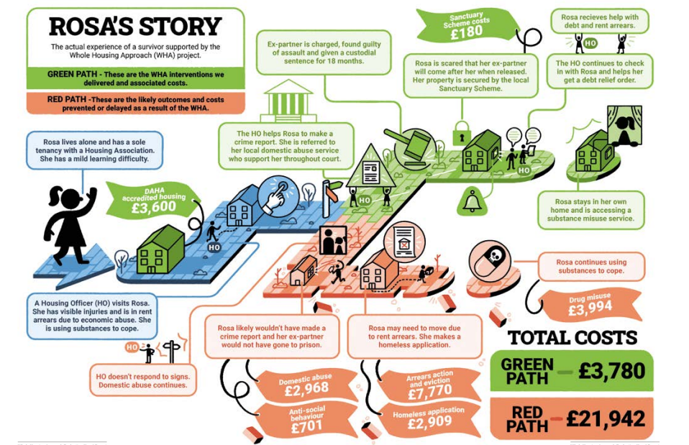

Case Studies

Total number of cases directly discussed- 23
Professionals were from the following agencies-
- Cambridge City Council Housing
- CGL
- IDVA service
- Probation
- Rape Crisis
- Refuge
Total number of survivors spoken to- 3
  - 6.1 Pathway Mapping- End to End Support Journey
Case Study- Number 1
Identification/ Entry Point
Referred through Change Grow Live (CGL) and Police
Victim Profile
Male, Late 40s, some physical illnesses
Client needed moved out of current accommodation where he was living in home with perpetrator and she owned the house.
Client needed and wanted to move town and get away from culture of street drinking and drugs. Client left situation with no ID, money, or clothes.
Victim/ Survivor Needs within Safe Accommodation
Client needed help to access public funds, open a bank account, get food and continued work on his alcohol and drug addiction. He was also previously a perpetrator of domestic abuse so needed support regarding his own behaviour.
Support given
A district council successfully got him out the town and into temporary accommodation.
Follow on Support
The client’s Independent Domestic Abuse Adviser (IDVA) helped him apply for public funds, get ID replacements, and open a bank account. The client was referred to a church where he could get hot meals during the day. Flexible funding was applied for to provide clothing. CGL continued supporting the client, including taking food parcels to the temporary accommodation. He was eventually offered permanent accommodation from the housing team at Fenland who had found him suitable accommodation, a bungalow, to account for his physical illness.
Outcome
Client died from drug related death. Prior to death client was very positive about his recovery and actively engaging with agencies. Moreover, agencies were successfully working together to support client.
Case Study- Number 2
Identification/ Entry Point
Cambridge City Council and Police
Victim Profile
Female, 30-40, full time carer for child with multiple disabilities.
Client had left abusive relationship on several occasions and reconciled. She was living with perpetrator when she became known to the service.
Client was in an extremely coercive and controlling relationship. It was unsafe to obtain documents as they were being locked away by perpetrator and equipment for child with disability were in house and it was hard to move.
Victim/ Survivor Needs within Safe Accommodation
The client needed accommodation suitable the needs of the child.
Support given
The housing advisor started by filling out the Domestic Abuse, Stalking and Honour Based Violence form. The housing team then worked with the police (who had awareness of situation through previous police report) and organised mechanism to engage with client through Cambridge and Peterborough Foundation trust, to ensure perpetrator didn’t become aware. Together with the police they were able to form an exemption for the client to show documentation and moved her to an emergency band to get her into social housing. Client was also supported by directing her to resources.
Follow on support
When offer for housing became available, Cambridge city council explained to housing officer the mechanism to contact the client.
Outcome
Client was moved within 2-3 months and remains safe.

Case Study- Number 3
Identification/ Entry Point
Police
Victim Profile
Female from A8 country with two daughters.
Female was referred from police to IDVA service due to an ongoing investigation into two offences. At the time the client became known to the service she had decided that she would travel back to her home country because she wasn’t aware of the support available.
Client and two children were at risk of sexual abuse in home country and therefore it was not safe to travel home. It was clear that the client felt pressured to travel home because she was not getting suitable assistance or support in the UK.
Victim/ Survivor Needs within Safe Accommodation
Accommodation suitable for herself and her two children.
Support given
The client’s IDVA informed social care about the risk to the children if the client was to return to her home country. A safeguarding meeting was planned and the IDVA and children’s social care team worked jointly to get client housing outside the area.
Follow on support
The client was reallocated outside the area into suitable accommodation with her two children.
Outcome
Client was housed in safe accommodation, working jointly with social care.
Case Study- Number 4
Identification/ Entry Point
CGL
Victim Profile
Female, aged 38, White British, children over 18 and a primary school child.
Perpetrator was long term client with CGL, and client’s son was referred for support from impact of father’s drug use.
Client was not financial dependent on perpetrator, she was employed and claimed benefits. However, due to bedroom tax her rent arrears had been significantly impacted.
There was a long history of DA with multiple call outs to the home. The case had been open for a period with early help, but parents were engaging minimally.
Couple would separate and reconcile on a weekly basis and during periods of separation, he would continue to harass the family by turning up at the house.
Despite the child being present during incidents of DA and on occasion was physically harmed when he intervened during a physical assault by the perpetrator, the risk was marked as low on the Domestic Abuse, Stalking and Honour Based Violence (DASH) form.
Victim/ Survivor Needs within Safe Accommodation
Client needs accommodation out of area with her son.
Support given
During this time CGL continued to work directly to support the child with his experiences and helped the client on an informal basis.
The case had not been referred to MARAC despite the escalation of risk and behaviour, CGL completed a further DASH form with the mother to refer to MARAC and the mother received IDVA support.
Client wanted to move property but wanted to stay in the area due to support network and son’s school and support. She was had rent arrears to pay and her housing association said she could not move until they have been paid off. This caused lots of distress for her and her son as they were continually being harassed by perpetrator.
The IDVA assisted the client in gaining a non-molestation order and helped her engage with the housing association about the housing issues.
Follow on support
In last contact discussion with housing were ongoing.
Outcome
Case ongoing.
Case Study- Number 5
Identification/ Entry Point
Refuge
Victim Profile
Female, aged 30-40, Lithuanian settled status, 2 children, she was employed but became unemployed and now on benefits.
When she became known to the housing team she had fled to refuge.
Victim/ Survivor Needs within Safe Accommodation
Needed 2-bedroom accommodation.
Support given
The refuge had already done a DASH with the victim, so the housing helped client to bid on housing register and she was supported to find a privately rented property.
There was slight language barrier but support worker at refuge was able to help communication and share relevant information.
The refuge pathway works well as refuge can provide emotional support while housing team seeks suitable accommodation.
Follow on support
Client continued to wait for accommodation to become available and stayed in refuge.
Outcome
Still awaiting accommodation.

  - 6.2 Survivor Engagement - Personal Experiences of Support
Survivor Feedback 1
Female client was being harassed at her residency by her ex-partner. Her ex-partner was breaking and entering he flat and looking through the windows. The Client had mental health difficulties including anxiety that was exacerbated at night when she was fearful of her ex-partner turning up at the property. This meant that the client could not sleep, making her anxiety and depression worse.
Services
The client was assigned an IDVA who was able to use flexible funding to get the client CCTV. The client had been trying to move property but had been struggling due to her rent arrears. With support from her IDVA she has now received a grant to cancel her rent arrears. Moreover, the IDVA has now got the client’s housing status changed.
Experiences
‘The CCTV has changed everything; I have actually had a full night sleep which has made a huge difference to my mental health’.
The client spoke very highly of her IDVA and said she had really built trust with her IDVA and was able to openly communicate with her IDVA about all aspects of her life.
The client did not feel refuge was a suitable option for her due to her specific needs. She has 3 children, her youngest has sensory needs and heavily relies on their dog. In a refuge setting the dog wouldn’t be allowed and she would be sharing a room with three children, which would further impact on her mental health.
Survivor Feedback 2
Female client had been at refuge and is now in her own accommodation.
Services
The client had spent time at Refuge, and they supported her to find housing for when she moved from refuge. She has now been provided suitable housing and has been provided flexible funding to purchase white goods for her new property including a fridge/freezer, lamp shades, cooker, mattress and a bed.
Experiences
The client was very grateful for her time at refuge, she said ‘‘Refuge have saved my life by giving me a fresh start, I can never, ever thank them enough for what they have done.’ She was appreciative of the support staff at Refuge and the other clients who had had built strong friendships with during her time. Moreover, she was able to start gardening while she was Refuge which was a very calming and therapeutic activity for her. She was very happy in her new home and the location. She was very surprised by the amount of flexible funding provided to her and expressed that she was extremely grateful and had made her experience moving significantly easier.
Survivor Feedback 3
Female client with 2 children, primary school age.
Services
Client was first moved to refuge due to physical and emotional abuse from ex-partner. The client has had to move refuge twice due to perpetrator finding out where she was located. She has also been placed in temporary accommodation and has now got privately rented accommodation. She has been recently assigned an IDVA who has supported the client massively. Moreover, the children are receiving support through their school and teachers have upheld good communication with client.
Experiences
Since the client was employed, she had to pay rent on the refuge accommodation while she continued to pay rent and council tax on the previous property she had fled from. Moreover, because she had fled with nothing for herself or her children, she needed to pay a lot of money out to buy necessities. This has caused the client to go into debt which she is still paying off. The client feels as though she is being punished for the perpetrator’s behaviour and penalised for being employed.
While in refuge because she was still working, the family had to be kept away from all the other clients due to the Covid-19 risk. This left the client and the children extremely isolated. Also, while in refuge there was no internet provided and no laptops so client could not home school her children.
The temporary accommodation that the client was placed in was not suitable for the family as they were surrounded by a lot of drug and alcohol misuse and loud and aggressive behaviours.
Her new permanent accommodation has no flooring but her IDVA has put in grant for a new carpet as the client can no longer afford to pay anymore outgoings.
The client feels as though she has lost her whole support system by moving out of area and only now has received an IDVA. Before moving to her most recent location she was given no consistent support for herself or her children. She feels that she and her children need therapy and counselling to work through what has happened. She is especially worried for her children who have been moved around, unable to sustain friendships.
The client has ongoing involvement in family and criminal courts and feels that the system is failing to protect her from ongoing harassment and abuse.
Survivor Feedback 4 (provided by client’s Outreach Support worker)
Female client in her late 30s. She was Black African, had 2 children and was employed. She was living with her partner in privately rented accommodation, along with her partner’s extended family. She had referred herself into the Refuge service due to physical, emotional, and psychological abuse by her partner. Moreover, the children had been abused by the perpetrator and his family.
Services
Refuge were able to explain her rights regarding immigration and her working visa arrangements. There were no vacancies for refuge, and she did not want to move outside her area due to employment. Refuge spoke with housing team at local authority, but she had no access to public funds and housing application was refused. Refuge spoke with social services and they helped get funds together to house the client and her children in temporary accommodation over the weekend.
Experiences
She decided not to leave and stay where she was. Social services let have let her stay with the perpetrator despite risk to children. Outreach support at Refuge have reached out to her since and offered help to flee from her current situation but she declined. Social services still have ongoing involvement with children.
Survivor Feedback 5 (provided by client’s IDVA)
Female client, 1 child in the UK and 2 children in China. She was Chinese and not employed in the UK. She could face deportation if her status was known to the authorities, but she couldn’t return to China due to risk of death for breaking 1 child policy and also leaving her marriage in China. Since she was married in China, she could not apply for concession to stay due to domestic abuse as she didn’t meet requirements.
Services
The client was supported by an IDVA who has signposted her to apply for asylum. The client now has a solicitor.
Experiences
Until she has successfully applied for asylum, she can’t access public funds. Moreover, there is a language barrier due to the client’s limited English. IDVA was able to support this client with legal route because of their own legal knowledge from working previously in this area of law. The process of applying for asylum or concession outside the regular rules causes significant delays to the process of getting the client into safe accommodation.
Survivor Feedback 6 (provided by client’s IDVA)
Female from a travelling community. She was living with perpetrator on traveller land at time of contact.
Services
Client was given an IDVA who helped support her to get out of the situation. Due to the high risk and isolated location of the community, the IDVA had to tactically arrange for the client to be picked up out of sight of the perpetrator. This was a hard process to manage due to the isolated nature of the community and risk of the perpetrator catching the client fleeing from their home.
Experiences
Client was successfully picked up and re-located to a refuge. However, when she first moved there was a lack of support for her complex mental health needs. Due to her mental health needs exacerbating she decided to reconcile with perpetrator. Abuse started again shortly after returning and she got back in contact with her IDVA. The Client has now been moved to another refuge in another location.
Survivor Feedback 7 (provided by client’s IDVA)
Female with 3-year-old and pregnant with perpetrator’s child. Client was living in same area as perpetrator.
Services
Client was being supported by an IDVA but due to the closeness of the perpetrator and the high levels of control, the IDVA was unable to do home visits or to implement the bobby scheme to make her property more secure. Client did not want to move away from current location, but local authority and social housing wouldn’t take her case unless it was to move outside the area.
Experiences
During a child protection conference, the client did agree to go into refuge accommodation. It was the IDVA’s opinion that the client felt pressured into this during the conference having previously expressed adamantly that she would not go into refuge. The client was taken to refuge and lasted one night before returning to her flat.
Client has now agreed to be moved outside her area and she is bidding every week for housing. Her IDVA and housing advisor have supported her in getting her Band B moved to a Band A. She is awaiting suitable accommodation and continues to get support from her IDVA as the perpetrator continues to abuse client.
Survivor Feedback 8 (provided by client’s IDVA)
Female client from A8 country. She was discharged from hospital after suffering from physical abuse. She had nowhere to go so her IDVA assisted her to local authority housing. It was late in the day and they were refused assistance. The IDVA explained the situation for urgent assistance but still they were refused.
Services
The IDVA was told that the client would get a call from emergency assistance, but they did not receive one.
Experiences
The IDVA took the client to go and stay with one of her friends until they could seek help in the following day. Client was told that she was not eligible for housing. IDVA had to support client and advocate for her client when working with other professionals. The IDVA felt undermined as a professional when advocating for this client and felt that she was discriminated on based on her own ethnicity (she was also from an A8 country). In total, the IDVA spent 2.5 days working on this one client to help her get into safe accommodation.

Conclusions and Recommendations

- The process of completing this needs assessment has highlighted that inconsistent data collection is a key concern across relevant local agencies. This is in particular relation to
  - Disability
  - Occupation
  - Sexual Identity
- A spectrum of response is required to meet varied needs of clients, dependent on their risk, household structure, occupation and tenure of property.
- Services need to ensure there is focus to meet the needs of some groups in particular:
  - Having staff who are able to communicate with Lithuanian and Polish women in their native language.
  - Enabling those from gypsy/traveller communities to access support
  - Ensuring services reach older people and provide an accessible service which meet specific needs.
- A high proportion of victims identified by the data gathered are living in social housing. This highlights the importance of housing providers and associations are working towards DAHA (Domestic Abuse Housing Alliance) accreditation.
- There is currently a lack of supported safe accommodation for men, women with teenage boys (including teenage children) and for others where shared refuge accommodation wouldn’t be appropriate.
- Mental health and substance misuse are the most common needs of women in refuge accommodation. They are also a key reason in women not being able to access refuge accommodation. There is a need for specialist refuge support for those women where there are complex needs and shared accommodation with children would not be appropriate, as well as requiring more support from staff.
- The number of children living/fleeing with victims of DA is not accurately recorded. This creates difficulties in ascertaining the need for suitable space for victims with child dependents
- There is a need for flexible support to ensure victims are able to live in safe accommodation – which may include increasing the safety of their own home, or alternative accommodation. Those suffering domestic abuse must be able to have choice and control of where they live and are able to maintain social capital (e.g. employment, schools, community support), for them and their children.
- There is often a need for emergency/temporary accommodation whilst other accommodation is arranged – this could be days or months, depending on a range of factors.
- No recourse to public funds and uncertain immigration status can be particular issues, where there can be huge barriers in accessing accommodation, and there is need to ensure they are support whilst applying for any relevant concessions.
- There is a need to ensure support is made available for those who are in local authority temporary accommodation due to fleeing domestic abuse.
- Relevant recommendations of the A Refuge for All project (Shaping Our Lives A Refuge for All Project and Findings Report – Shaping Our Lives) should be implemented including;
- refuge spaces that are accessible for a range of disability needs not just wheelchair access,
- using the Social Model of Disability over other models,
- - considering personal care needs of women in refuges and how these can be provided safely.
- Ensure there are suitable accommodation options for victims over 60, with or without care and support needs, where residential or respite care would not be appropriate and including where the victim needs domiciliary care.

Appendix 1: ‘DASV: Safe Accommodation Needs Assessment Survey- April 2021

Description of the survey (carried out online in April 2021)
Responses Completed: 112
- Please tick the box that best describes your current role.
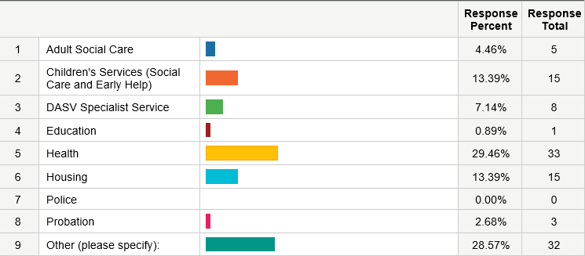
All respodents answered.
Others included: Nursery practioner, youth support worker, member of fire service, substance misuse worker, member of religious group.
- How often do you work with victims/ survivors of DA?
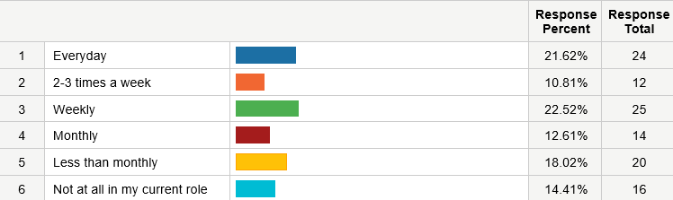
One respondent skipped.

- In your experience, which of the demographics have acted as a barrier to ensuring safe accommodation for DA victims/ survivors? You may select several of the options.
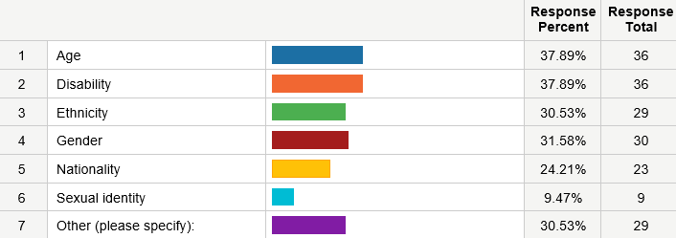

Ninety-five respondents answered, seventeen skipped.
Others included: wanting to stay close to family/friends, no recourse to public funds, accommodation can’t accommodate large families, client wants to stay in area while agencies want to move her away from risk area, older adults more apprehensive about separating from abuser, stigma among community/ fear of reprisal from the family, not having legal status to be in the UK, having older children, their occupation (e.g. sex working), not enough emergency accommodation, complexity of needs/ multiple disadvantage, lack of accommodation for male victims, complex needs including substance misuse, mental health and criminal history, area you reside in, personal capacity linked to age and vulnerability.
- 4. In your experience, which of the following options have acted as a barrier to ensuring safe accommodation for DA victims/ survivors? You may select several of the options.
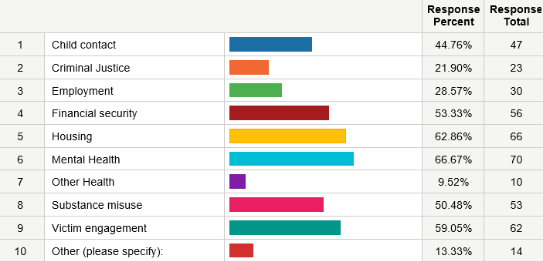

One hundred and five respondents answered, seven skipped.
Others included: home ownership, communication/ British Sign Language, children with SEN, lack of understanding and knowledge by professionals on the complexity of needs, having children, no recourse to public funds, male victims lack options, pets, resistance to move away from support system, criminal history, children and their school and friends, lack of transport leading to isolation, success is dependent on the professional supporting with accommodation.
- Is there anything else you would like to add on the subject of accessing safe accommodation for DA victims/ survivors?
Thirty-one respondents answered, eighty-one skipped.
- Geographical location as a barrier
- Hard for professionals to help client urgently find safe accommodation because of busy schedules and high workload
- Difficulty in getting Band A for mothers, there should be an identified housing officers who deals with DA cases
- Poverty as main issue
- Clients suffering from severe isolation once moved to safe accommodation due to communication needs- there isn’t a specialist refuge with BSL staff in the UK
- Need for local and non-local options that are easily accessible
- Need to educate the community and specific cultures
- No recourse to public funds as major issue
- Cambridge Women’s Aid were incredible
- Fire service can provide smoke alarms and fire-retardant mail guard to prevent ignition/spread of fires through letter boxes
- Lack of accommodation available
- Difficulties of joint tenancies
- There needs to be emergency places for perpetrator to be removed from family home, client and children feel guilty making perpetrator homeless
- Housing advisers don’t ask the right questions- women are often given dangerous accommodation, mixed accommodation where they are financially abused, assaulted, bullying, harassment. Also issues where women were not offered accommodation under she engaged around her addiction but perpetrator was continually sabotaging this help for her.
- Increased information sharing so that staff understand needs of abused, how to get necessary information to ensure safety and appropriate accommodation so that choice is not between safety and homelessness
- The need for a more trauma informed process
- Need to pay for transport out of area
- Not enough emergency accommodation
- Lack of accommodation for male victims
- Multiple occupancy private houses offering support should be vetted, ensure female only houses where there are vulnerable women- should be able to anonymously report the supported housing supplier
- The need for an ongoing supportive relationship
- More training for professionals and agencies (continued victim blaming)
- Feelings of isolation
- Ongoing abuse through child arrangement applications
- More acceptance of client needs including alcohol use, criminal history, mental health
- Raising awareness in communities to let victims know what is available
- There is a perpetual tension between finding safe accommodation 'out of reach' of a perpetrator and removing a vulnerable woman away from all her support networks. Many of the young women I support are more scared of living away from their families (the unknown) than living close to their perpetrators (the known).
- Older clients unsure about shelters and refuges as they are geared towards younger women

Spotlight #1: Older people and domestic abuse | Safelives
ibid
Domestic abuse victim characteristics, England and Wales - Office for National Statistics (ons.gov.uk)
Male_Reporting_Paper_Apr 15 FINAL.pdf (cambridgeshire.gov.uk)
Domestic abuse victim services, England and Wales - Office for National Statistics (ons.gov.uk)
ibid
Suzie*'s story: a trans woman's experience of domestic abuse | Safelives
LGBT Service - Independent Choices (domesticabusehelpline.co.uk)
ibid
Domestic abuse prevalence and victim characteristics - Appendix tables - Office for National Statistics (ons.gov.uk)
Spotlight #6: LGBT+ people and domestic abuse | Safelives
ibid
ibid
Outcomes for disabled people in the UK - Office for National Statistics (ons.gov.uk)
Disabled Survivors Too CORRECTED.pdf (safelives.org.uk)
ibid
ibid
ibid
ibid
SafeLives' response to the Commission on Race and Ethnic Disparities Race Report | Safelives
Supporting B&ME victims – what the data shows | Safelives
Supporting B&ME victims – what the data shows | Safelives
Population of the UK by country of birth and nationality - Office for National Statistics (ons.gov.uk)
VOSNA-2020-Executive-Summary_Final.pdf (cambridgeshireinsight.org.uk)
Cambridgeshire County Council, Cambridgeshire & Peterborough Needs Assessment: Victims, Suspects and Offenders 2019/2020 Executive Summary (2020) < VOSNA-2020-Executive-Summary_Final.pdf (cambridgeshireinsight.org.uk)>
ONS, Domestic abuse prevalence and trends, England and Wales year ending March 2020 (November 2020) < Domestic abuse prevalence and trends, England and Wales - Office for National Statistics (ons.gov.uk)>
ONS, Domestic abuse in England and Wales overview (2020) < Domestic abuse in England and Wales overview - Office for National Statistics (ons.gov.uk)>
NSAW Paladin Bulletin (2020) < NSAW Paladin Bulletin - Paladin Service>
ONS, Domestic abuse during the coronavirus (COVID-19) pandemic, England and Wales (November 2020) < Domestic abuse during the coronavirus (COVID-19) pandemic, England and Wales - Office for National Statistics (ons.gov.uk)>
Ibid [n1]
ONS, Homicide in England and Wales (2021) < Homicide in England and Wales - Office for National Statistics (ons.gov.uk)>
Cambridgeshire County Council, Community Safety Strategic Assessment: South Cambridgeshire 2020/21, (2021) < South-Cambridgeshire-Strategic-Assessment-202021-v1.0.pdf (cambridgeshireinsight.org.uk)>
Population of the UK by country of birth and nationality - Office for National Statistics (ons.gov.uk) Cambridgeshire Insight – Population – Local Population Estimates and Forecasts
Captive & Controlled Domestic Abuse in Rural Areas – 2019 < Domestic-Abuse-in-Rural-Areas-National-Rural-Crime-Network.pdf (ruralabuse.co.uk)>
Cambridgeshire County Council ‘Cambridgeshire & Peterborough Needs Assessment: Victims, Suspects and Offenders: 2019/2020 (2020) < VOSNA-2020-Report_Final.pdf (cambridgeshireinsight.org.uk)>
Supporting B&ME victims – what the data shows | Safelives
Imkaan (2012) Vital Statistics 2: Key findings report on Black, Minority Ethnic and Refugee Women's and Children's experiences of gender-based violence. London: Imkaan <https://www.imkaan.org.uk/resources>
01_2017_FCSP_DHR_Full_Report.pdf (fenland.gov.uk) and domestic-homicide-review-report-2018-05.pdf (cambridge.gov.uk)
Ibid
Domestic abuse victim characteristics, England and Wales - Office for National Statistics (ons.gov.uk)

